Image show and information of image:

Code:

w=imread('CT-head.jpg');

figure,imshow(w);

figure,imshow('CT-head.jpg')

imfinfo('CT-head.jpg')

Output:

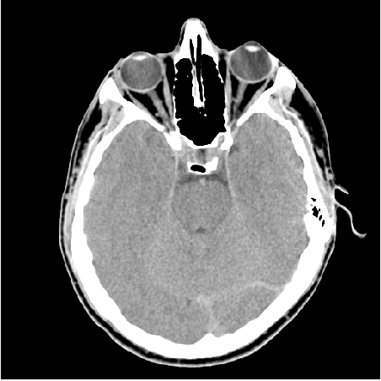

Figure 5.1: Output of imshow command

Image Information:

ans =

struct with fields:

Filename: 'E:\4-2\BME Lab\Lab5 Image processing\CT-head.jpg'

FileModDate: '06-Dec-2016 12:08:32'

FileSize: 90990

Format: 'jpg'

FormatVersion: ''

Width: 512

Height: 512

BitDepth: 8

ColorType: 'grayscale'

FormatSignature: ''

NumberOfSamples: 1

CodingMethod: 'Huffman'

CodingProcess: 'Sequential'

Comment: {}

Resolution:

x=imread('Brain.jpg');

subplot(331)

imshow(x)

title('original image');

subplot(332)

x1=imresize(imresize(x,1/2),2);

imshow(x1)

title('resize 1/2');

subplot(333)

xn=imresize(imresize(x,1/4),4);

imshow(xn)

title('oresize 1/4');

subplot(334)

a=imresize(imresize(x,1/8),8);

imshow(a)

title('resize 1/8');

subplot(335)

b=imresize(imresize(x,1/16),16);

imshow(b)

title('resize 1/16');

subplot(336)

c=imresize(imresize(x,1/32),32);

imshow(c)

title('resize 1/32');

subplot(337)

d=imresize(imresize(x,1/64),64);

imshow(d)

title('resize 1/64');

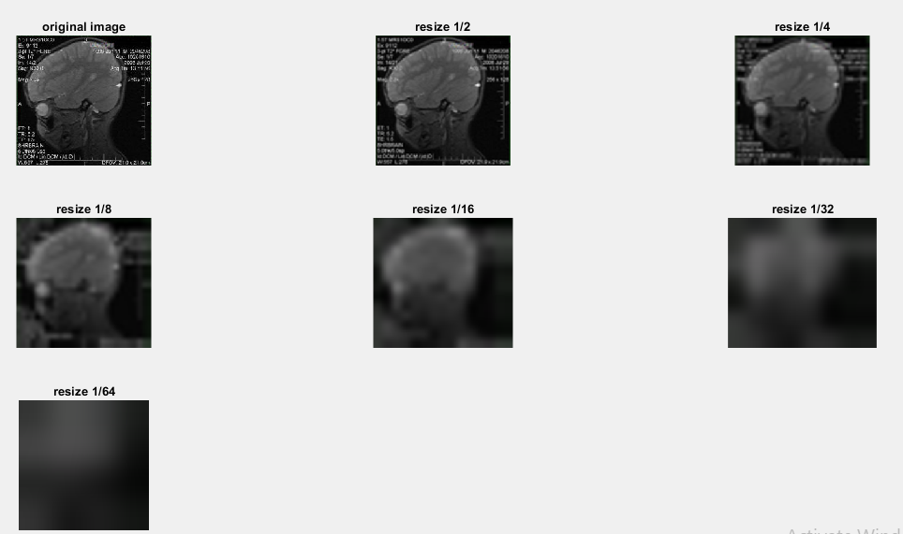Output:

Figure 5.2: Output of different image resolutions

Different noise and filter:

Code:

%Noise Analysis:

tw=imread('Vrain_tumor MRI.jpg');

%salt and pepper noise

tn=imnoise(tw,'salt & pepper');

figure()

subplot(231)

imshow(tn)

title('image with salt and pepper noise')

subplot(232)

tr=medfilt2(tn);

imshow(tr)

title('noise remove with median filter')

fspecial('average',[5,7])

f1=fspecial('average');

cf1=filter2(f1,tn);

subplot(233),imshow(cf1/255)

title(' sp remove with average filter')

%gaussian noise

tg=imnoise(tw,'gaussian');

subplot(234)

imshow(tg)

title('image with gaussian noise')

subplot(235)

tr=medfilt2(tg);

imshow(tr)

title('noise remove with median filter')

fspecial('average',[5,7])

f1=fspecial('average');

cf1=filter2(f1,tg);

subplot(236),imshow(cf1/255)

title(' noise remove with average filter')

%speckle noise

tgs=imnoise(tw,'speckle');

figure()

subplot(231)

imshow(tgs)

title('image speckle noise')

subplot(232)

tr=medfilt2(tgs);

imshow(tr)

title('noise remove with median filter')

fspecial('average',[5,7])

f1=fspecial('average');

cf1=filter2(f1,tgs);

subplot(233),imshow(cf1/255)

title(' noise remove with average filter')

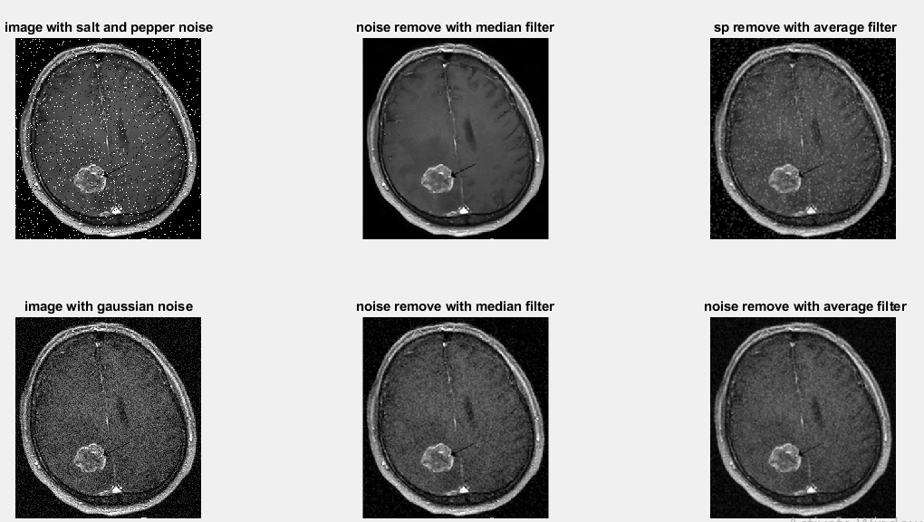Output:

Figure 5.3: Salt and pepper noise, Gaussian noise removal with median and average filter

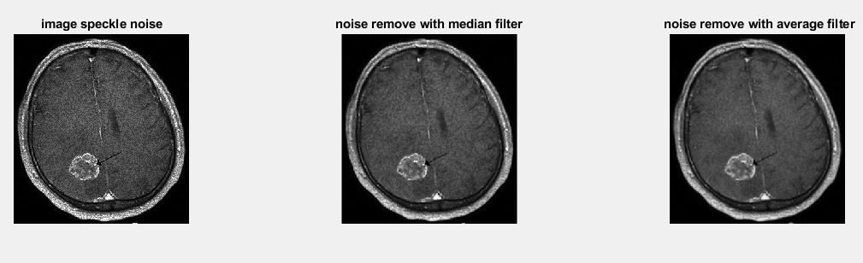Figure 5.4: Speckle noise removal with median and average filter

Edge detection:

Code:

%Edge detection:

a=imread('CT-head.jpg');

subplot(224),imshow(a)

title('original image');

edge_p=edge(a,'prewitt');

subplot(221),imshow(edge_p)

title('Edge detection with prewitt');

edge_r=edge(a,'roberts');

subplot(222),imshow(edge_r)

title('Edge detection with roberts');

edge_s=edge(a,'sobel');

subplot(223),imshow(edge_s)

title('Edge detection with sobel');

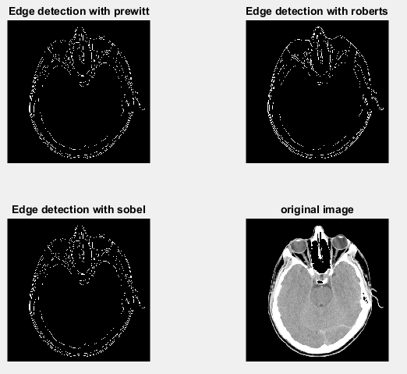

Figure 5.5: Edge detection with prewitt, Roberts and sobel operator

Histogram Analysis:

Code:

%Histogram:

w=imread('fracture.jpg');

subplot(221),imshow(w),title('original image'),

subplot(222),imhist(w),title('histogram'),axis tight

p=imread('fracture.jpg');

ph=histeq(p);

subplot(223), imshow(ph),title('histogram equalized image'),

subplot(224),imhist(ph),title('histogram equalization'),axis tight

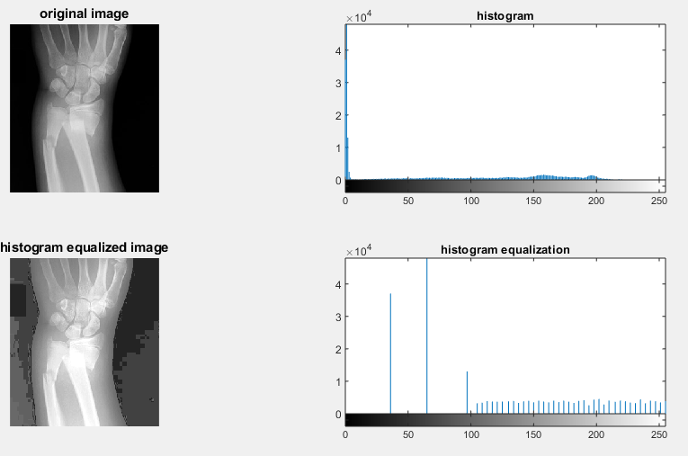

Figure 5.6: Histogram and histogram equalization of an image